**GALLANT IAS ACADEMY**

**CURRENT AFFAIRS**

**JUNE 20-JUNE 26**

**Index**

**Polity**

1. National Education Policy 2020
2. Prevention of Money Laundering Act, 2002
3. Pension Fund Regulatory and Development Authority

**IR**

1. India- Bangladesh
2. India-China

**Economics**

1. GST
2. Development of secondary sector
3. Insolvency and Bankruptcy board of India

**Ecology**

1. Pobitora WLS
2. Invasive alien species

**Geography**

1. Hindu Kush Himalaya
2. Critical minerals
3. Heat waves

**Science and tech**

1. China’s sample return lunar mission
2. Potassium cyanide
3. Pushpak

**Sources-** The Hindu, The Indian express, Business Line, PIB, official websites

**National Education Policy 2020**

GS2- Issues relating to development and management of Social Sector/Services relating to Health, Education, Human Resources

“The new National Education Policy (NEP) 2020 is the first education policy of the 21st century in India, which replaces the previous National Policy on Education (NPE) 1986.“

**Foundational Pillers**

1. Access - age 14(72%), age 18(44%)
2. Equity- STEM women (28%) men (36%)
3. Quality- 45% male and 42% of female can do a basic maths problem (age 14-18)
4. Affordability
5. Accountability

Source - Pratham ASER Report(Annual status of education)

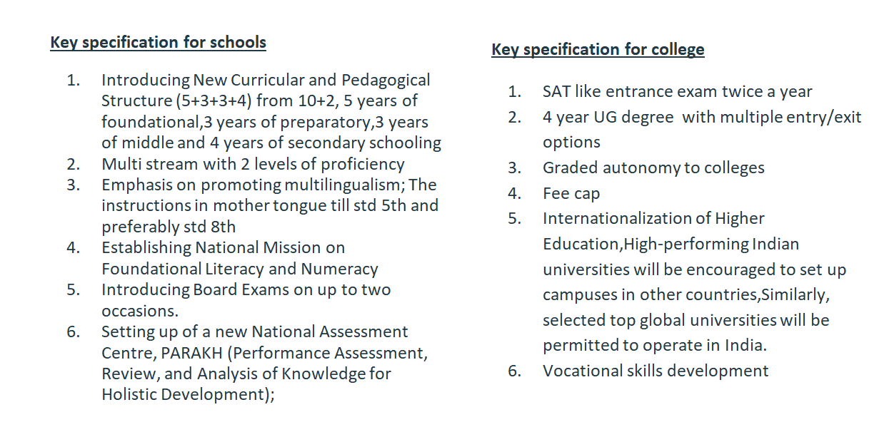

**Prevention of Money Laundering Act, 2002 (PMLA).**

GS2-Government policies and interventions aimed at development in various sectors and issues arising out of their design and implementation.

GS3- Basics of cyber security; money-laundering and its prevention

PYQ 2021-Discuss how emerging technologies and globalisation contribute to money laundering. Elaborate measures to tackle the problem of money laundering both at national and international levels. (150 words, 10 Marks]

**Section 45, PMLA 2002**

1. Bail is not the rule but exception under PMLA
2. **Twin Test- :** (i) that there are “reasonable grounds for believing that [the accused] is not guilty of such offence” (ii) that “he is not likely to commit any offence while on bail”

**Issues**

1. It’s not a ‘Reasonable Classification’- right to equality
2. Against the rights against self- incrimination - article 20(no ex post facto law,no double jeopardy)
3. Against presumption of innocence until, proven guilty

**Pension Fund Regulatory and** **Development Authority (PFRDA)**

Statutory body- the PFRDA Act, 2013.

Ministry of Finance

Obj- To promote old age income security, protect the interests of subscribers

Schemes managed

1. NPS- open to employees from the public, private, and even unorganised sectors, except those from the armed forces(18-65).
2. Atal Pension Yojana- a universal social security system for all Indians, especially the poor, the under-privileged and the workers in the unorganised sector.(18-40)

**INDIA-BANGLADESH Relations**

GS2- International relations

PYQ2020-Analyse internal security threats and transborder crimes along Myanmar, Bangladesh and Pakistan borders including Line of Control (LoC). Also discuss the role played by various security forces in this regard. (250 Words 15 Marks)

Context- Sheikh Hasina on 2 day visit

**History**

1. Partition of India-1947
2. Language movement 1952
3. Bangal liberation war 1971- Mukti bahini, sheikh Mujibur Rahman, Awami league, Yahya khan, operation searchlight, INDO- Soviet friendship treaty
4. INDO- Bangladesh treaty of friendship, cooperation and peace in 1972
5. Military coup of Mujibur Rahman
6. Sheikh Hasina as P.M
7. Security and Border management-( Bangladesh-India) land boundary agreement,coordinated border management plan,100CAA
8. Trade- comprehensive economic partnership agreement,2022 , largest trading partner
9. Connectivity- Akhaura-Agartala Rail Link, access to Chattogram and Mongla ports in Bangladesh ,Matarbari port, cross border rail link,
10. Energy, water and power- maitre thermal power plant,rooppur nuclear project
11. Multilateral- BIMSTEC, IORA, SAARC

**Issues**

1. **Economic relations and policy issues**- FDI policy 2017
2. **Border Management and security-** Jamaat-ul-mujahideen Bangladesh
3. **Humanitarian refugee issues-** Rohingya
4. **Water sharing concerns**- teesta water sharing agreement
5. **Political and Diplomatic challenges**- CAA
6. **Strategic Challenges-** China

**INDIA- CHINA**

GS2-India and its neighbourhood

Context- P.M will be in same place and time as of Chinese president during SCO leaders summit

Shanghai cooperation Organisation- political,economical , military org

1.Kazakhstan 2. China

3. Kyrgyzstan 4. Russia

5. Tajikistan 6. Uzbekistan 7. India

8. Pakistan

**Issues**

1. Border Issues- Ladakh(Aksai chin),Johnson line,macdonald line eastern side(Arunachal Pradesh, Sikkim Manmohan line,)
2. Border Incursions- Demchok 2014,Doklam 2017,Galwan 2020
3. Water sharing- Brahmaputra dam,
4. Trade imbalance- 87 billion trade deficit
5. BRI- China Pakistan economic corridor
6. Salami slicing strategy
7. Debt trap diplomacy
8. Five fingers of Tibet strategy- Ladakh, Nepal, Sikkim,Bhutan, Arunachal
9. String of pearls

**Recent issues**

1. Exchange on social media platform ‘X’ by **Mr. Narendra Modi** and Taiwan’s president **Mr.Lai Ching-te**
2. A seven member delegation from U.S met **Dalai Lama** in Dharamshala- Xizang independence, resolve Tibet act(U.S congress)
3. “Dis engagement” and “De Escalation” to “patrolling rights” and “patrolling abilities”
4. Centre-Left P.M Anthony Albanese(from Scott Morrison) of Australia engaging with China

**GST**

GS3- Indian Economy and issues relating to Planning, Mobilization of Resources, Growth, Development and Employment.

PYQ2020-Explain the rationale behind the Goods and Services Tax (Compensation to states) act of 2017. How has COVID-19 impacted the GST compensation fund and created new federal tensions? (250 words, 15 Marks)

“GST stands for Goods and Services Tax, which is a comprehensive indirect tax imposed on the supply of goods and services at each stage of the production and distribution chain. It is aimed at replacing multiple indirect taxes levied by the central and state governments, thereby creating a single unified tax system”

1. 101 CAA
2. GST-VAT, cascading effect
3. Subsumed many state and central taxes- not included (tax on tobacco, alcohol,electricity, petroleum poducts)
4. Destination based tax
5. Inverted duty structure

HW- cess and surcharge

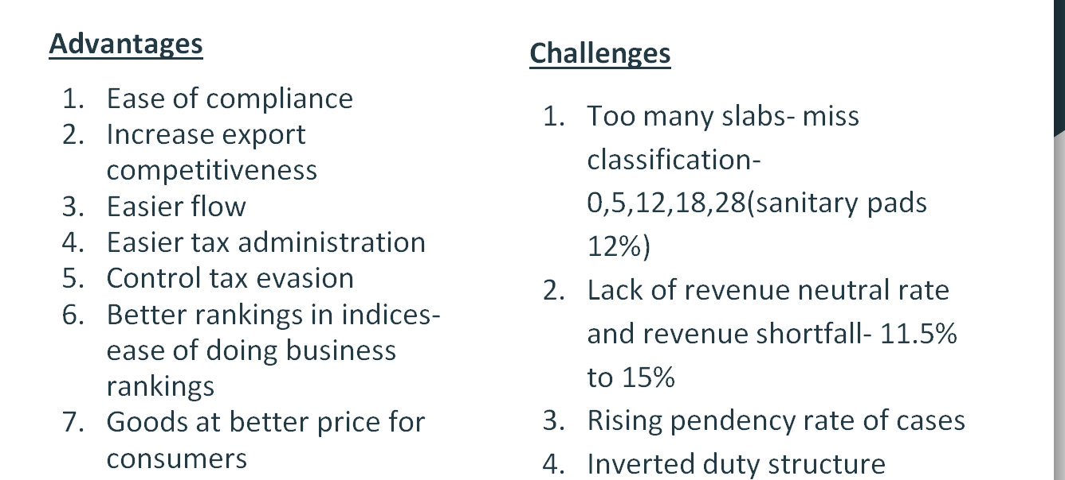

**Development of Secondary sector**

GS3-.Changes in Industrial Policy and their Effects on Industrial Growth.

PYQ- “Industrial growth rate has lagged-behind in the overall growth of Gross-Domestic-product (GDP) in the post-reform period.” Give reasons. How far are the recent changes in Industrial-policy capable of increasing the industrial growth rate? (250 words, 15 marks)

Context: manufacturing sector contribution to GDP from 16-13

**Significance**

1. Employment generation- agri(GDP 18,43%) manufacturing( 25%) service (30%)
2. Supply chain development
3. Economic growth
4. Promote export
5. Attract foreign investment
6. Infrastructure creation

**Government initiatives**

1. National manufacturing policy 2011-2025 100 million jobs and gdp 25% secondary
2. PLI- 14 sectors
3. Infrastructure- Sabarimala,bharatmala,sez,dedicated freight corridors
4. Consolidation of labour laws- 4 labour codes code on Wages,Industrial Relations Code,Social Security Code,Occupational Safety, Health and Working Conditions Code
5. FDI relaxation
6. Reclassified msme, corporate tax reduced

**Issues**

1. Labour laws- regulatory cholesterol
2. Land acquisition
3. Investment in R&D
4. Complex taxation
5. Inadequate infrastructure- 2% of NH 40% of traffic
6. Access to finance -
7. Missing middle- middle class industries absent
8. Technology adoption

**Way forward**

1. Coastal economic zones- China model
2. Focus on sunrise sectors- AI,IoT
3. Nurturing start-ups-angel investors and venture capitalists
4. Facilitating investment
5. Plug and play model land
6. Skilling India- PMKVY

**Insolvency and Bankruptcy Board of India (IBBI)**

* It was established as a statutory body in 2016 under the Insolvency and Bankruptcy Code, 2016.
* Ministry of corporate affairs
* Individual,companies,limited liability partnership and partnership firms
* The board may exercise the powers that of a civil court

**Objectives**

1. Speed up insolvency proceedings
2. Consolidate laws
3. To protect interest of creditors and debtors
4. Maximise value of debtors assets

**Pobitora WLS**

PYQ 2019- Consider the following statements:

1. Asiatic lion is naturally found in India only.
2. Double-humped camel is naturally found in India only.
3. One-horned rhinoceros is naturally found in India only.

Pobitora WLS- highest density of one-horned rhinos in the world

* second highest concentration in Assam after Kaziranga National Park.
* Water hyacinth (an invasive aquatic plant) is a major problem to the area
* India rhino vision 2020 location

**Rhinos**

1. IUCN- Vu
2. Solitary
3. Gestation period 15-16 months
4. Usually single calf

**Invasive Alien Species**

GS3- ecology and environment

Context- Kenyan govt plans to kill house crows using poison

Invasive Species Specialist Group’ (that develops Global Invasive Species Database) belongs to which one of the following organizations?

a) The International Union for Conservation of Nature

b) The United Nations Environment Programme

c) The United Nations World Commission for Environment and Development

d) The World Wide Fund for Nature

Impact

1. Ecological
2. Economical
3. Health
4. Social

**Hindu Kush Himalaya**

GS1- World geography

PYQ.How will the melting of Himalayas glaciers have a far-reaching impact on the water resources of India? [150 Words, 10 Marks]

Context; report by International Centre of Integrated Mountain Development on low snow persistence in river basin

* Contributes 23% of run of for 12 major river basins including Ganga
* Reasons- prolonged El-Nina, La-Nina,weak western disturbance

**Impacts**

1. Irrigation
2. Hydro power
3. Drinking water
4. Transboundary disputes

**Way forward**

1. Reforestation
2. Weather forecasting and early warning systems
3. Black carbon emission reduction- albedo
4. Water use efficiency and infra
5. Regional cooperation
6. Community involvement
7. Reduce emissions

**Critical Minerals**

GS1-Distribution of Key Natural Resources across the world (including South Asia and the Indian sub-continent);

**About**

1. For manufacture of modern tech
2. Strategic supply chain disruption
3. China as global leader
4. Most of dem are imported in India

**Steps by india**

1. Co Investing in S.America
2. Rare earth mineral deposit in Africa
3. KABIL- Khanij Bidesh India Ltd. (KABIL)
4. India-U.S. Initiative for Critical and Emerging Technology (iCET)
5. Critical mineral investment partnership with Australia

**HeatWaves**

GS3- disaster management

Context ; heatwave in North India,

PYQ-Q. Bring out the causes for the formation of heat islands in the urban habitat of the world.[100 Words, 5 Marks]

**Disaster Management Act,2005**

1. Catastrophe or grave occurrence
2. Natural or man made
3. Beyond coping capacity
4. 45 degree or ⅘ degree change

NDRF and SDRF

1. Reluctance of finance commission-10%
2. Financial Implications
3. Attribution of death to heat wave

**China’s sample return lunar mission**

GS3 - awareness in the field of space

PYQ-Launched on 25th December, 2021, James Webb Space Telescope has been much in the news since then. What are its unique features which make it superior to its predecessor Space Telescopes? What are the key goals of this mission? What potential benefits does it hold for the human race? (250 words, 15 marks)

1. China’s CHANG’E 6 - first to bring samples from far side of moon
2. South Pole-aitken basin
3. Analyse the sample- origin of earth, minerals, possibility of life
4. Preserved for future missions
5. Help other inter planatory missions

**Potassium cyanide**

GS3 -Science and Technology- Developments and their Applications and Effects in Everyday Life.

Q. Brominated flame retardants are used in many household products like mattresses and upholstery. Why is there some concern about their use?

1They are highly resistant to degradation in the environment.

2. They are able to accumulate in humans and animals.

Select the correct answer using the code given below.

1. KCn
2. Soluble in water, toxic
3. Non combustible
4. Use- gold mining,organic synthesis,photographic fixer

**Pushpak**

GS3- awareness in the field of space

Space x- Falcon 9;is a reusable rocket

Context- ISRO successfully tested reusable launch vehicle landing experiment (REV- LEX) at Chitradurga, Karnataka

1. Autonomous landing capability
2. Winged vehicle
3. Low cost access to space
4. Flying test bed for various technologies